Nirakar Shrestha

Professor Wise

CS 320

Assignment 11

**Ping:** It is used to test whether or not the source computer can reach to a specified computer. Simply, it is used to verify the connection between two devices in a network

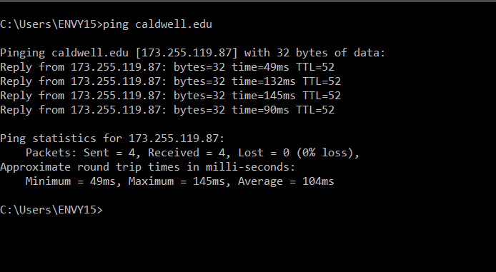

**Traceroute:** Command used to show the path taken by a packet of data to reach a destination computer from the source computer. 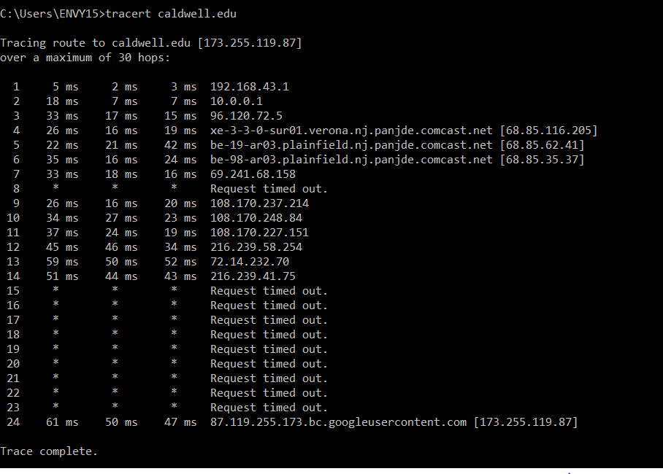

**Nslookup:** It is used for querying the DNS to obtain DNS records such as IP address, domain name, etc.

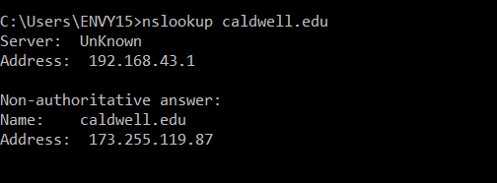

**IPConfig:** It is used to display the IP Configuration of a computer

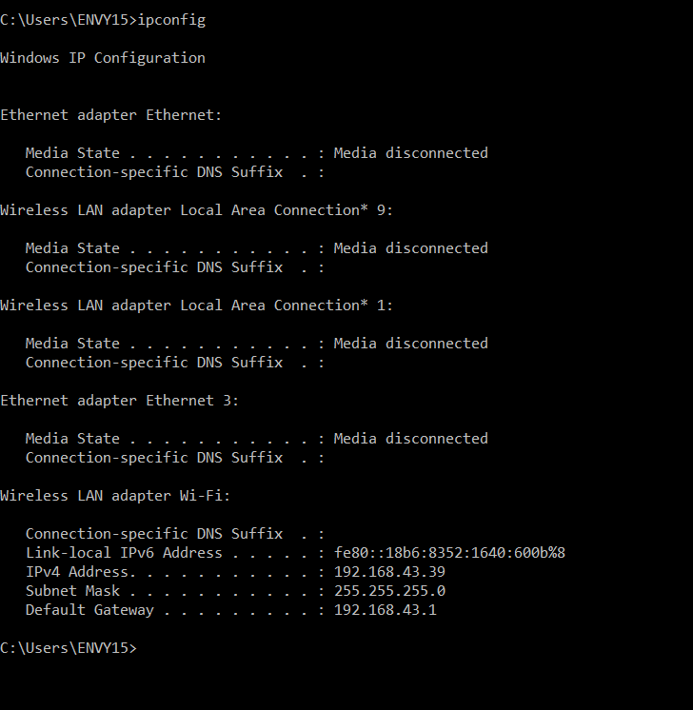

**Netstat:** It is a network utility tool used to display network connections for the TCP, routing tables, and network interface. 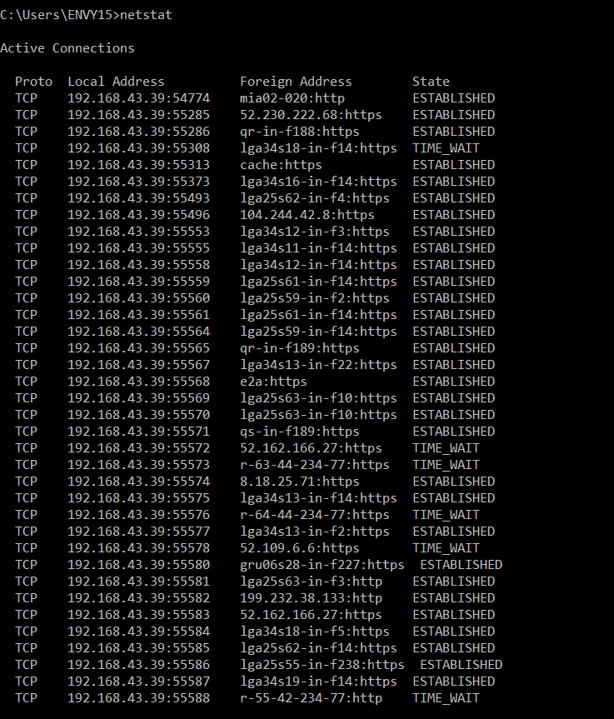

**Route print:** Displays the interface list. IPv4 and IPv6 route table

